Mining User’s Real Social Circle in Microblog

# data source

We obtain data from SinaWeibo, there are a lot of API and crawler already. Our data consists of two parts, one is user’s personal information, another is user’s bilateral follower list.

1. User’s personal information, consists of these fields,

* UserName, Id, Gender, birthday and general informations like these
* Contact informations
* Education background
* User’s tag about himself/herself
* The number of followers and followees
* V titles if the user is a V user

1. User’s bilateral follower, consists of these fields,

* Follower list and the number of follower
* Followee list and the number of followee

# analysis methods

1. Circle discovering
   1. For a certain user, we collect all his bilateral friends as neighbours
   2. For a certain user c, we iterate all his neighbours v to cluster them into circles
   3. For every circles of c, we find out the users should be in the circle but are not the neighbor of c yet.
2. Method of clustering
   1. Define V_NEIGHBOR(a) = all the bilateral followees of a
   2. Define Sa,b = V_NEIGHBOR(a) ∩ V_NEIGHBOR(b)
   3. Define the distance between a node named *node* and a cluster(circle) named *clu*, *c* is the center user we want to analyse, *num* is the number of existing member of the cluster *clu*.

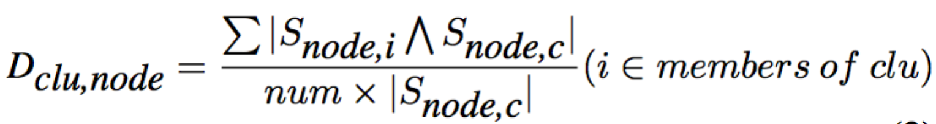

* 1. Clustering:

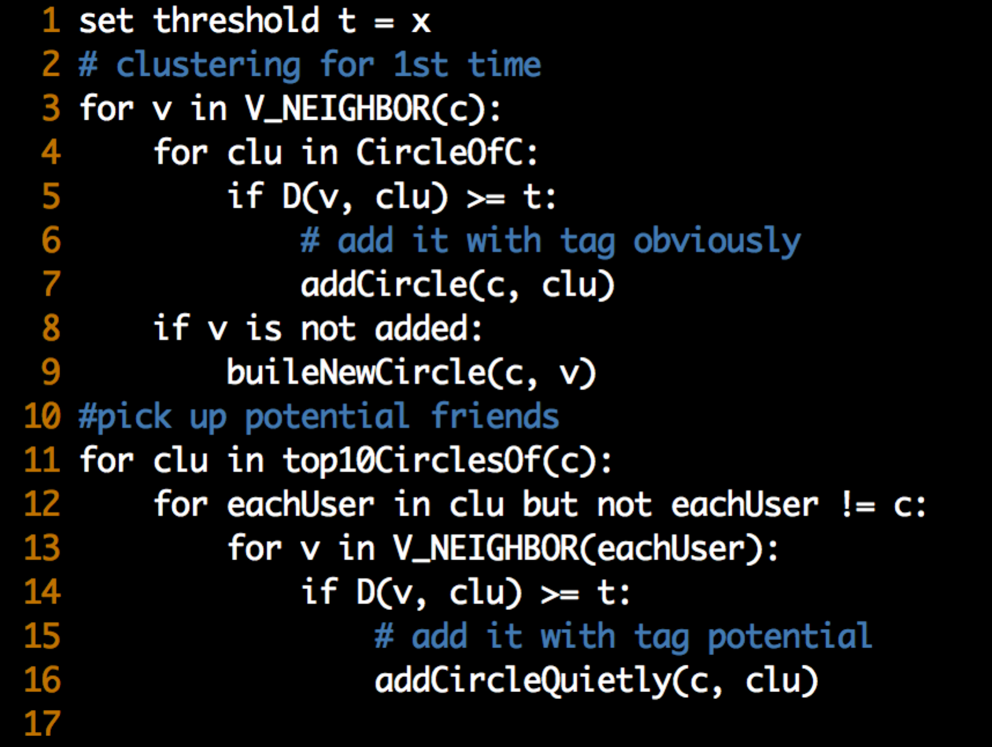

1. Circle analyzing

Naïve analyzingUsing the basic information for every person in the circle to label a circle, it maybe, polling method is used here.

# applications

* Analysis someone’s social circles, to know more about this person in Recruitment.
* Effective promotion. We can accurately do the promotion in the circles with certain label if we can tag the circles automatically
* Recommand a potential friend exists in a certain circle but the user having folloew him/her.